Java script Assignment Theory

1.What Is Java Script ?

Ans. Java Script is a client side scripting language and server side scripting language. Java Script is dynamic view of our website. 14lake+ Library and famous library jQuery react-Js and famous Framwork is next-Js on backend side.

This language is case sensitive language or single threaded , synchronous language.

2. What is the use of is NaN function? (NaN – Not A Number)

Ans. The JavaScript isNaN Function is used to check whether a given value is an illegal number or not.

3. What is negative Infinity?

Ans. Negative Infinity is a special numeric value is returned when an arithmetic operation and mathematical function generates a negative value greater then the largest representation number in java script. (i.e., more negative than -Number. MAX_VALUE)

4. Which company developed JavaScript?

Ans. Netscape Communication developed by java script.

5. What are undeclared and undefined variables?

Ans. Undeclared variable means variable is not initialized earlier using the var or const keyword.

Undefined variable means variable is defined but not assign value is as called as undefined variable. Undefined is not keyword.

Exp. Let = myName (Undefined)

6. Write the code for adding new elements dynamically?

Ans. Var user = document.createElement(“div”)

7. What is the difference between ViewState and SessionState?

Ans.

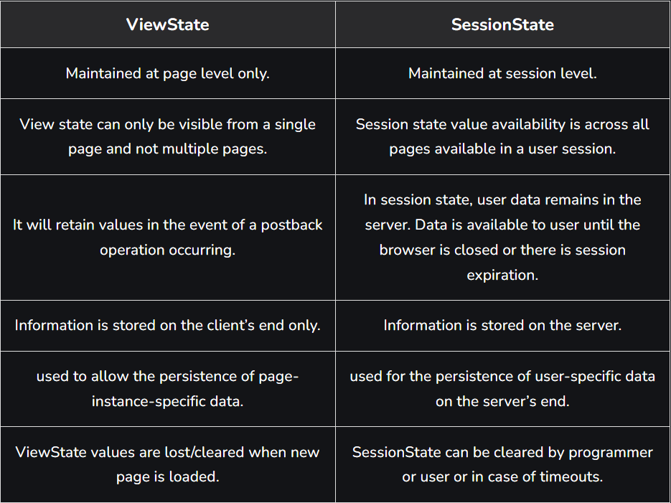

8. What is === operator?

Ans. === is Comparison Operators.

9. How can the style/class of an element be changed?

Ans. Document.getElementById(“Head”).style.Display = “None”

Property = New Style

10. How to read and write a file using JavaScript?

Ans.

11. What are all the looping structures in JavaScript?

Ans.

For Loop – For loop is continue return value and Every time return new value as called as for loop.

For in loop – For in loop is manipulate objects key

For of Loop – For of loop is manipulate string

While Loop – While Loop is one time value initialize and then again use this value in looping as called as While loop.

Do While Loop – Do While Loop One time loop is work and then after condition check then after condition is true then loop is work sand condition is false then loop is not work.

ForEach loop – ForEach loop is functional loop.

12. How can you convert the string of any base to an integer in JavaScript?

Ans. parseInt(string_value)

13. What is the function of the delete operator?

Ans. The Delete operator remove a property From an object.

14. What are all the types of Pop up boxes available in JavaScript ?

Ans. Mainaly Three types of Pop up boxes as well as follow :

1. Alters ()
2. Confirm()
3. Prompt()

15. What is the use of Void (0)?

Ans. JavaScript void (0) means returning undefined (void) as a primitive value.

16. How can a page be forced to load another page in JavaScript?

Ans. window.location.href = “URL” that is redirect on another page.

17. What are the disadvantages of using innerHTML in JavaScript?

Ans. **Replacement is done everywhere –** Do modify and any one changed

**Used for Cross-site Scripting -** The text and images or elements in the webpage can used by hackers or malicious users to change.